

FACULTY OF COMPUTING

SEMESTER 1 2023/2024

**SECP1513-TECHNOLOGY & INFORMATION SYSTEM**

**SECTION 2**

**GROUP ASSIGNMENT: DESIGN THINKING**

**TITTLE :**

**COMPUTER SOFTWARE**

**LECTURER :**

**DR ARYATI BINTI BAKRI**

|  |  |
| --- | --- |
| **Name** | **Student ID** |
| **ELIJAH SHE YU SHENG** | **A23CS0073** |
| **CHEW CHIU XIAN** | **A23CS0061** |
| **TAN ZHI MING** | **A23CS0189** |
| **NG YU HIN** | **A23CS0148** |

**TABLE CONTENTS**

|  |  |  |  |
| --- | --- | --- | --- |
| **1.0** | **INTRODUCTION** |  | **1** |
| **2.0** | **DETAILED STEP AND DESCRIPTION** |  | **1** |
| **3.0** | **DETAILED DESCRIPTION** |  | **6** |
| **4.0** | **DESIGN THINKING ASSESSMENT** |  | **6** |
| **5.0** | **DESIGN THINKING EVIDENCE** |  | **7** |
| **6.0** | **REFLECTION** |  | **8** |
| **7.0** | **THE TASK FOR EACH MEMBER** |  | **9** |
| **8.0** | **WORK PROGRESS** |  | **10** |
| **9.0** | **REFERENCE** |  | **11** |

**1.0 INTRODUCTION**

In design thinking, inventors create or modify applications, employing critical thinking to meet users' needs. The core principles are empathy, ideate, prototyping, and iteration adapt to solve complex problems, ensuring effective, user-friendly solutions. There are many types of computer software, such as educational software, utility software, application software, enterprise software, programming software and system software. However, our report mainly delves into educational software, emphasizing the importance of tailored solutions within this broader domain.

Top of Form

**2.0 DETAIL STEP AND DESCRIPTIONS**

**Empathy**

In this stage, we will be interviewing two lecturers UTM who are experts on application software to understand the problems of the educational software that causing difficulties to students and staffs in UTM. The tables below are the details of the interview sessions.

 *Table 1: Detailed Interview Session 1*

https://scholar.google.com/citations?user=DTI3M0YAAAAJ&hl=en

|  |  |
| --- | --- |
| **Title** | **Content** |
| Name | Dr. Ahmad Najmi Amerhaider Nuar |
| Occupation | Lecturer in Universiti Teknologi Malaysia |
| Question | What are the problems that faced by students and also lecturer in UTM now? |
| Answer | The educational software needs a feature for generating comprehensive attendance reports. A proposed solution is a button for students to submit absence reasons within the app, streamlining communication with UTM lecturers. Additionally, the app's timetable should include details beyond academics, offering a more user-friendly experience with information on transportation, sports facilities, canteen hours, and more. This aims to ensure seamless study progress and provide a comprehensive platform for both lecturers and students, enhancing efficiency and convenience in educational processes. |

*Table 2: Detailed Interview Session 2*

|  |  |
| --- | --- |
| dr pt1**Title** | **Content** |
| Name | Dr. Nur Eiliyah Wong / Wong Yee Leng |
| Occupation | Lecturer in Universiti Teknologi Malaysia |
| Question  https://scholar.google.com/citations?user=Ku-Lq_0AAAAJ&hl=en | What is the problems that faced by students in UTM now? |
| Answer | The UTM Portal faces issues like unclear event details and email spam. Recommendations include incorporating comprehensive event information for direct registration, displaying on-campus restaurant details, and utilizing a Google Form for sports facility bookings. These enhancements aim to create a more user-friendly and efficient platform for the UTM community, and your consideration is appreciated for ongoing portal enhancement. |

**Define**

After the interview session, we have understood that the problems faced by students are unclear about the details of the events, unable to know the information about the canteen, hard to book the sport facilities, unsure about availability of transport in UTM, hard to access and not receiving feedback quickly.

**Ideate**

After discussing with our group members, we decided to create an app to overcome the problems above. The app integrates all essential features into one comprehensive app. Includes important announcements, sports facilities, canteen hours, transportation, event registration, notifications, and educational news. Calendar integration for syncing important dates and events provides a centralized hub for student information.

**Prototype**

“Educational Application” is a well-rounded app which not only include important announcements, sports facilities, canteen hours, transportation, event registration, notifications, and educational news, it also has calendar integration that syncing important dates and events, so that we won’t miss any important events, thus providing centralized hub for students information.

**Feature of “Educational Application”**

|  |  |
| --- | --- |
| **characteristic** | **Description** |
| **NOTIFACTIONNotification Button** | The feature integrates time and event scheduling, with a drop-down for adding notes. Reminders can be set up, and the interface conveniently displays important dates below the calendar for easy tracking. |
| **Operating Hours Button**  **AFEfor Canteen** | The feature showcases restaurant information and operating statuses across colleges. Clicking a food icon leads to a new interface with available restaurants, and selecting a restaurant displays its menu, streamlining exploration and menu browsing.**Top of Form** |
| **Event Registration**  **INFOButton** | The feature integrates a college info button, showcasing events by clicking a college name. The calendar color-codes past and ongoing events, and clicking a date reveals the event list. Simplified event registration is facilitated through the "Register Here" button, providing a form and event details. |
| **BUSTransport Availability Notification Button** | The transportation feature in UTM offers detailed information. Users can choose between "Bus UTM" or "Other Bus" and access external apps like Maxim, Kumpool, Lugo, Grab, AirAsia, and RedBus. "Bus UTM" enables specific real-time bus searches, displaying the entire journey when selected. Users can set personalized arrival notifications through the star icon, enhancing the overall user experience. |
| **Sport Facilities**  **Button**  **SPORT** | The sports facilities feature lets users check availability and book courts through a Google form. Clicking the button leads to a selection section where users choose the sport, view details, and select date, time, and court, updating availability. Upon completion, a QR code is generated for efficient entry. |
| **SURVEYFeedback or Survey Button** | The feedback feature enables users to ask questions and provide feedback. Click "Others" to access the developer survey in the help center, including contact details. After clicking "Fill up survey form," users can submit feedback, confirmed by a "Thank you" page, ensuring effective communication. |

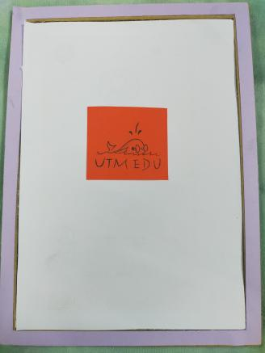

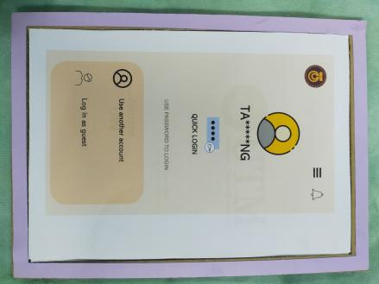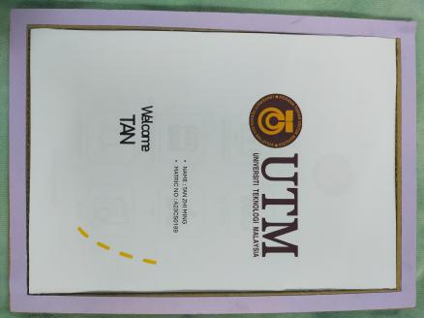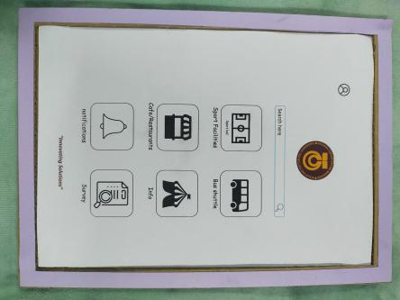

**1 2 3 4**

1. This is the logo for our UTM EDU app.
2. This is the login page to the app which requires user Password.
3. This is the page which declare the user is successfully log in the app.
4. This is the Menu page which include all the feature.

**5-8.**  These pages are the section about the detail of the sport facilities.

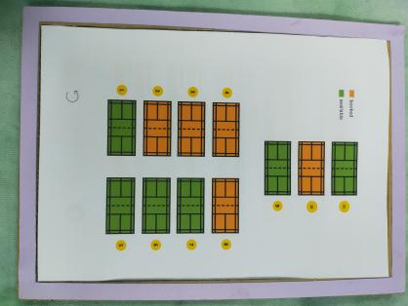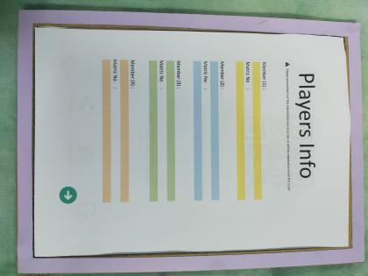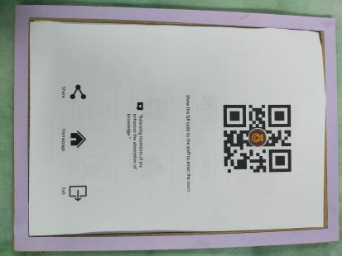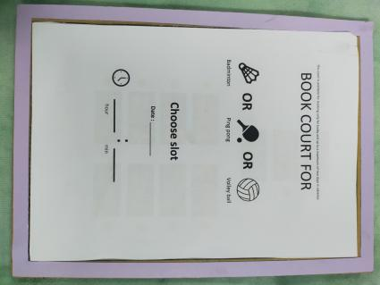

**5 6 7 8**

**9-11.**  These pages are the section about the detail of the transport availability.

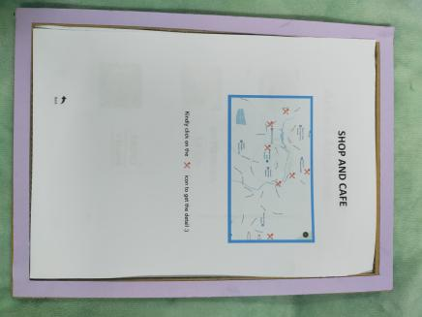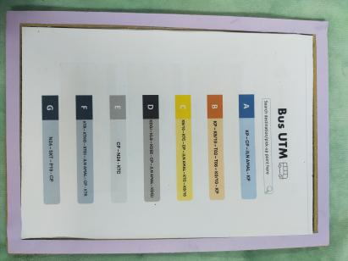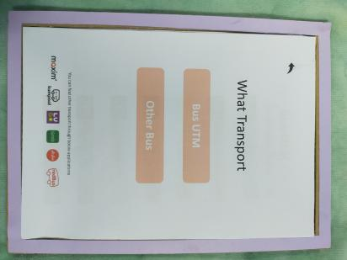

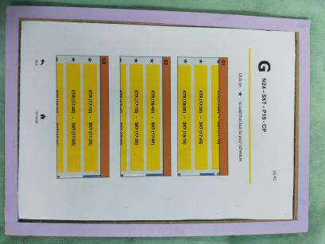

**9 10 11 12**

**12 - 14:** These pages are section about the info of food court

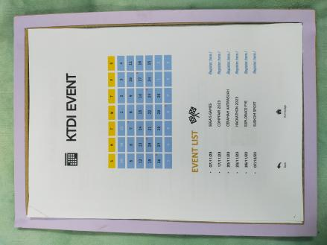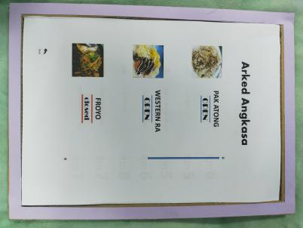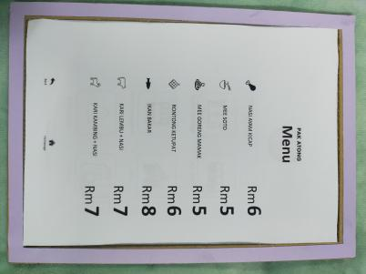

**13 14 15 16**

**15 - 19:** These pages are details of event registration section

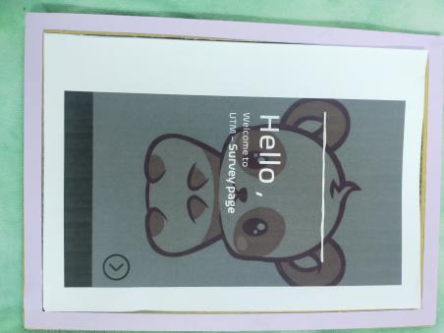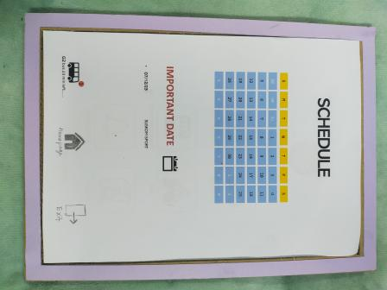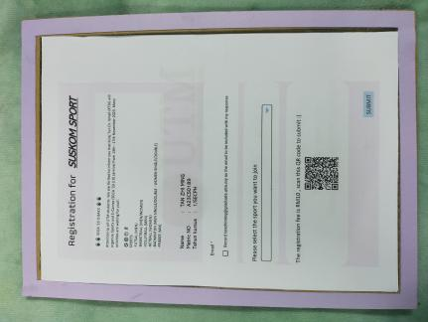

**17 18 19 20**

**20 - 24:** These pages are the feedback or survey section

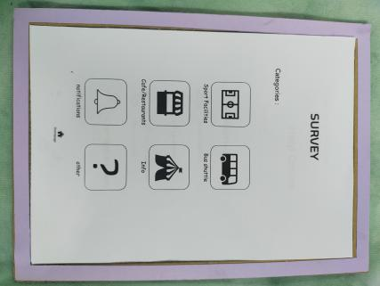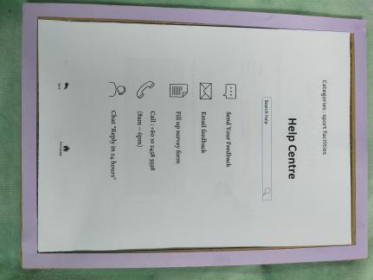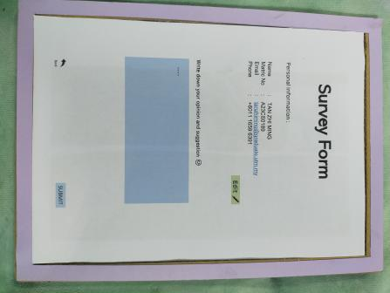

**21 22 23 24**

**Test**

After we finished the prototype, we decided to test our product to UTM students in Data Engineering course. We explained in detail about the functions of the app and how it benefits them in daily life. They gave us positive feedback that this solution would benefit them on overcoming the problems faced in daily life while in UTM.

**3.0 DETAILED DESCRIPTION**

PROBLEMS

Post-interview, we identified student struggles with uncertain sport hall availability, food court operating hours, and bus notifications. Real-time transport updates cause unnoticed bus misses. Notification overload results in missing crucial event notices, and challenges in finding event registration forms lead to missed event opportunities.

SOLUTIONS

Our app tackles challenges by offering easy sport hall reservations, real-time bus schedules, and driver notifications. Merchants update food court hours to reduce confusion. Users mark events for personalized notifications, and direct registration streamlines event and course sign-ups, enhancing daily experiences at UTM.

TEAM WORKING

Efficiency was achieved by dividing tasks: Tan Zhi Ming and Ng Yu Hin handled video production, while Elijah She Yu Sheng and Chew Chiu Xian managed report content. Despite initial design thinking challenges, collaborative efforts, interviews, tests, and prototyping ensued. Potential scheduling difficulties arose, but individual task clarity prevailed, leading to a successful report and video production.

**4.0 DESIGN THINKING ASSESSMENT**

**4a. DURING THE END OF THE PROJECT DEMONSTRATION**

Project completion revealed the importance of detailed design thinking, emphasizing understanding users' perspectives for fitting solutions. Creating an application is manageable, but ensuring it meets market needs and is profitable demands significant time and effort.

**4b. DURING THE TRANSITION BETWEEN DESIGN THINKING PHASES**

Early in the Design Thinking process, challenges like a lack of ideas and limited time for project discussions emerged due to academic busyness. Despite these hurdles, effective teamwork and cooperation allowed us to overcome challenges and complete tasks in each phase successfully.

**5.0 DESIGN THINKING EVIDENCE**

**Sample Work**

|  |  |
| --- | --- |
| Interview in the empathy stage | interview  interview2 |
| Discussion for define stage | define |
| Discussion for ideate page |  |
| Prototype stage |  |
| Test stage |  |

**6.0 Reflection and conclusion**

By Elijah She Yu Sheng

My goal is to creatively respond to community input and develop educational computer software to enhance university life quality. Our student-focused software created by design thinking enhances daily tasks, addressing challenges like time constraints. This project deepened my understanding of educational software's significance and design thinking's value.

Top of Form

By Chew Chiu Xian

My goal is to improve my problem-solving and critical thinking skills. Design thinking fosters diverse problem perspectives, shifting from assumptions to expert collaboration for effective problem understanding and solution identification. Then, also benefits me by improving my communication skills by communicating with different person.

By Tan Zhi Ming

For this course, I'm dedicated to mastering data engineering, leveraging the 2U2I program for fast IoT industry entry. Design thinking sharpens my problem-solving across IT roles, maintaining a lifelong learning approach, especially in data engineering. This assignment emphasizes early design thinking, optimizing educational software for improved student and developer outcomes.

By Ng Yu Hin

In this course, I aspire to refine analytical and soft skills while mastering problem-solving through design thinking. Collaborating with teammates, I aim to generate innovative ideas, continuously learning from mistakes, and embracing the unknown outside my comfort zone for constant self-improvement.

Top of Form

**7.0 THE TASK FOR EACH MEMBER**

|  |  |  |  |  |  |  |
| --- | --- | --- | --- | --- | --- | --- |
| **Name** | | Tan Zhi Ming | Ng Yu Hin | Elijah She Yu Sheng | | Chew Chiu Xian |
| **Task** | **Interview, Discussion, Prototype and Test Sections** | Interview and test | | | | |
| Producing Prototype | | User testing and iteration | | |
| Discussion for Define and Ideate Stages | | | | |
| **Documentation and Presentation** | Editing Videos | | Slide Presentation | | |
| **Report** | Progress tracking | Graphics and visuals | Introduction, Detail Description for Each Phase, Outline Creation | | Detail Description About Problems, Solution and Team Working, Assessment Point |
| Design Thinking Evidence | | | | |
| Final revision, review and feedback | | | Reflection | Merge and Compile the Report |

Video link: <https://www.youtube.com/watch?v=AEObz1Dx_Mo>

**8.0 Work Progress**

October 2023 – November 2023

* **First meeting** （**discuss problem)**
* **Go UTM DIGITAL to book appointment for interview**
* **Compose email to digitalcaremail to digitalcare**
* **Outline creation of report**
* **Start shooting video content**
* **Start doing prototype**
* **Interview with expert(Dr Nur Eiliyah)**
* **Email to academic office to get approval letter**
* **Interview with expert (Dr Ahmad Najmi)**
* **Finished out prototype**
* **Review prototype**
* **User testing part(prototype)**
* **Finished shooting every content that video need**
* **Start editing video**
* **Finished out the report prototype**
* **Final examining and giving feedback**

|  |  |  |  |  |  |  |
| --- | --- | --- | --- | --- | --- | --- |
| **SUN** | MON TUE | | WED | THU | FRI | **SAT** |
| 29 | 30 | 31 | 1 | 2 | 3 | 4 |
|  |
| 5 | 6 | 7 | 8 | 9 | 10 | 11 |
| 12 | 13 | 14 | 15 | 16 | 17 | 18 |
|  |  |
| 19 | 20 21 | | 22 | 23 | 24 | 25 |
| 26 | 27 28 | | 29 | 30 |  |  |

**9.0 References**

1. Pappas, C. (2015, April 9) The Top 6 Benefits of Design Thinking in eLearning. eLearning Design and Development, from

<https://elearningindustry.com/the-top-6-benefits-of-design-thinking-in-elearning>

1. Design Thinking: The Beginner's Guide. Interaction Design Foundation, from

<https://www.interaction-design.org/courses/design-thinking-the-beginner-s-guide-ver1>

1. 20+ Best Education Software in 2023: Key features of top Education Tools. (2023, October 10). Research.com.

<https://research.com/software/best-education-software-key-features-of-top-education-software>